**Homework #1**

**MSiA Program, Fall 2018**

**Optimization**

**Due: Problems 1-6 due at the start of class on 10/08/18 (Monday), the other 4 are due on 10/09/18 (Tuesday)**

1. If X, Y, and Z are decision variables, which of the following relationships are valid in a linear program. Briefly explain why for each of your answers.
   1. X + Y = Z
   2. XY <= 100
   3. 3X + 2Y <= 
   4. X + 2Y = 50
   5.  + 10Y = 100
   6. X2 + Y2 >= 45

------------------------------------------------------------------

***Note on problems 2-10***

A good way to learn linear programming is to do it. If you’ve done it before, you can still get insight from these models. For each of the problem, build the model in Excel or Python (I prefer Jupyter Notebooks), or both if it helps you learn. In Excel, solve with OpenSolver (or use Excel’s Solver if you have to—I think it is a little buggy and not as robust as OpenSolver). In either case, I want you to learn Linear Programming. So, make sure you understand the model, make sure you can explain the answer, and convince yourself that you have the right answer.

You will turn in your assignment as a group. But, I strongly recommend that you actually build each of these models yourself. This will serve you well and help you learn the material.

We will discuss each model in class. I will assign each group one of the problems to talk about. I will assign which problem your group will talk about ahead of time. You and your group should be able to explain the model and answer questions about it. The questions could be technical (about the model), business related (how would a business person think about the model), or data related (why do you think the answer was 3?). I also want to hear about mistakes you made or different things you tried. And, I want to know why you think your final answer is right. *You should treat this like a short presentation-*- y*ou can prepare a slide or two for your presentation and be ready to run your model if needed. I want to do two things: I want you to practice presenting the results of an analysis and I want us all to learn more about each model by asking more questions about it.*

1. Formulate and solve the “Two Products – Three Machine” problem from Class #1 as a linear program. Also, how would you set up this model so you could scale it? That is, how would you structure it if you had a lot of machines and a lot of products?
2. Your non-vegetarian friend wants to determine how many units of different kinds of meat he should eat to get the right amounts of vitamins A, C, B1, and B2 over the week. He also wants to minimize his cost. What should his diet be? How would you modify the linear program to make it “better?” You can find the cost for each unit of food and the percent of daily requirements for each vitamin type in the spreadsheet.
3. Solve the gas blending problem introduced in class. That is, determine how much of each type of gas you should buy and what you should use it for. Make sure you can explain the full model and especially the blending constraints.
4. Solve the nurse scheduling problem introduced in class. You want to know the minimum number of nurses needed to cover the 24-hour period. You can assume that the next day is the same as this one.
5. Cutting Stock Problem. You need to cut large rolls of 20 foot rolls of paper to meet your orders. The following are your orders:

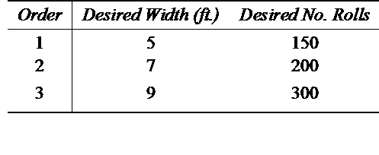

For example, if you had orders for a 10 foot roll, 8 foot roll, 6 foot roll, you could fill two of the orders with by cutting one 20-foot roll for the 10 and 8 foot order. Then, you would need to use another 20 foot roll to fill the demand for the 6 foot order. Of course, in this situation, you would waste 2 feet on the first roll and 14 feet on the other.

You need to minimize the number of total 20-foot rolls to fill the total demand.

For this problem, you need to formulate a linear program to minimize the number of 20-foot rolls. You must meet the total demand for the rolls listed above. For this homework problem, you need to do the following:

* Identify the decision variables
* Formulate a linear program to solve the problem
* Solve the linear program and determine the minimum number of 20-foot rolls you need.

1. Transportation Problem.

For this problem, assume there are two coal mines that feed four power plants. Mine #1 has 230 tons available, Mine #2 has 150 tons. The plants need the following tons:

* Plant #1: 80
* Plant #2: 100
* Plant #3: 70
* Plant #4: 130

The cost per unit to go from each mine to each plant is:



For this problem, formulate this as a linear program and find the minimum cost solution.

1. Assignment Problem.

This is a simplified version of the shelf space model. In this model you need to determine which product will go onto which slot on the shelf. For each product, at each location, you know the expected daily profit as seen in this table (which is also in the Excel file):

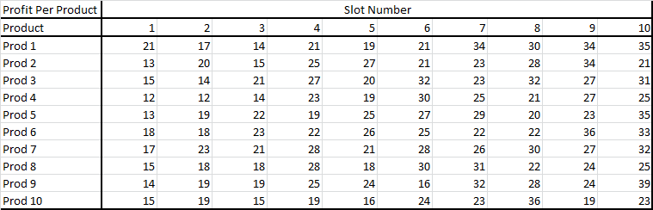

You need to determine what product should be slotted in which location. Only one product can go in each location and each product can only be slotted once.

Once you have your model built, determine what the absolute worse slotting would be. What is the business value for calculating this?

Also, determine the profit if each item was slotted in its best possible location- not considering the overall feasibility of the solution. What does this number tell you from a business point of view?

1. Simplified Berlin Airlift Model.

Do the problem in the Berlin Airlift PDF. Note, that you need to make a few modifications.

(For some reason, this problem did not do a good job of keeping track of time periods).

You need to modify:

* Assume that each plane can make 21 trips per week
* Assume that the total weekly budget is $7,000,000

Instead of the directions they give for solving the problem, do this:

* Set up the model in Excel (you should at least try this in Excel and if you like try it in Python too) and solve with OpenSolver
* What if the budget was $5,000,000, what is the solution? What is wrong with the solution? What are at least two ways to resolve this problem?

1. You are working for a distributor of vegetables. You can see the data on the vegetables in the spreadsheet. You have the price that you purchase, the price you sell, and the minimum quantity you have to sell (by contract), the max you can sell (the most the market will bear), and the cubic feet per carton. In your business you receive cases of vegetables from your suppliers at the start of the week. Your warehouse only has room for 18,000 cubic feet of product. And, your supplier only allows you to purchase up to $30,000 of product per week.
   1. Set this up and solve as a linear program
   2. What insights do you get from the solution.